Google Big Query

|  |  |
| --- | --- |
| **Summary** | To Setup a new project and explore Datasets |
| **URL** | <https://console.cloud.google.com/marketplace/product/obfuscated-ga360-data/obfuscated-ga360-data?filter=solution-type:dataset&q=analytics&project=level-elevator-303319&supportedpurview=project>  <https://console.cloud.google.com/bigquery> |
| **Tools** | Google Big Query |

Setup New Project

Explore Data set

3 Lesson Learned

# Setup New Project

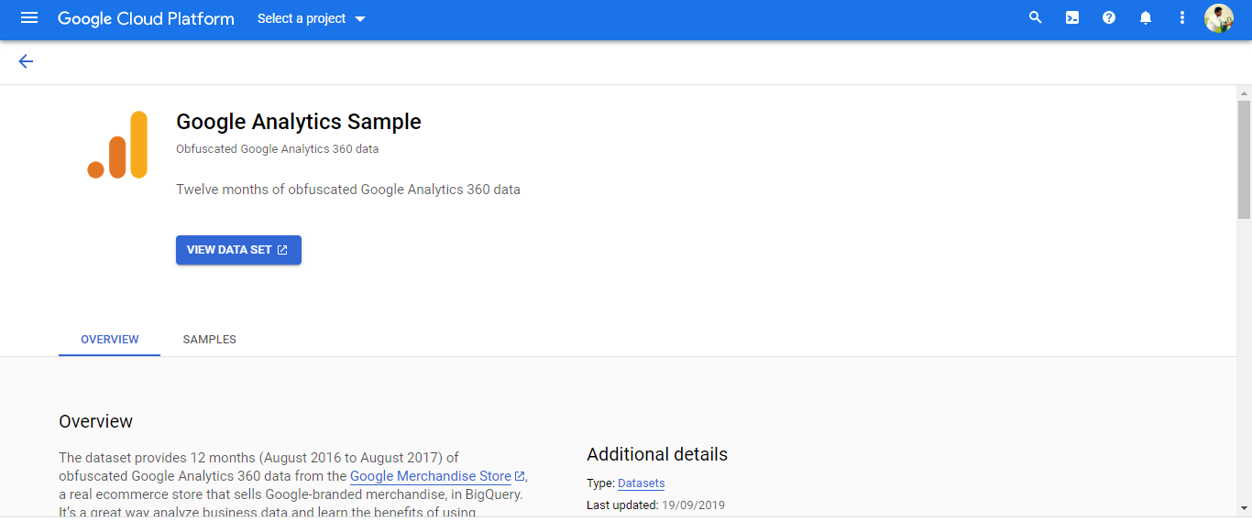

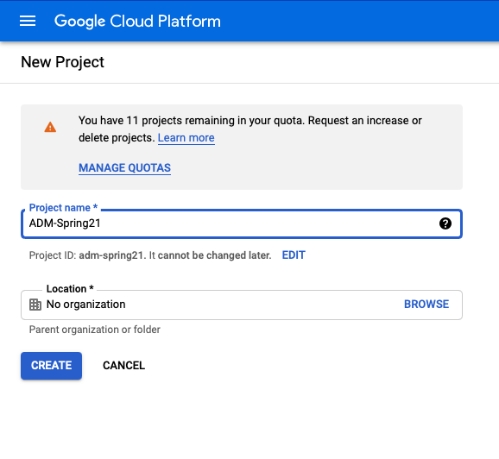

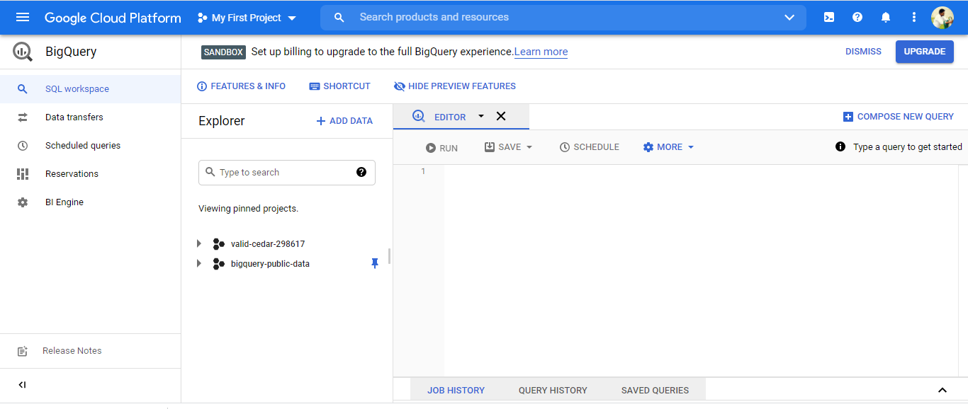

# 

# 

# Explore Data set

The following Questions where executed:

1. **What is the average number of transactions per purchaser?**

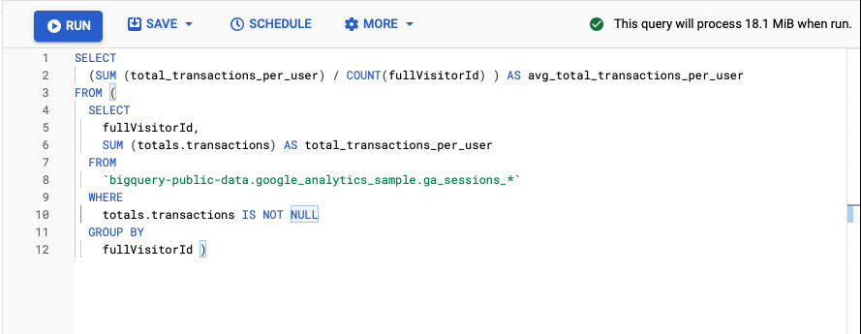

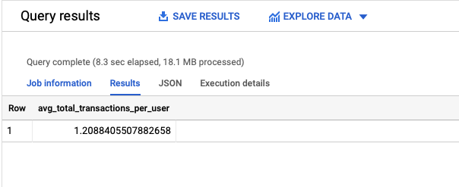

1. **Calculate the average number of transactions per purchaser for April 2017.**

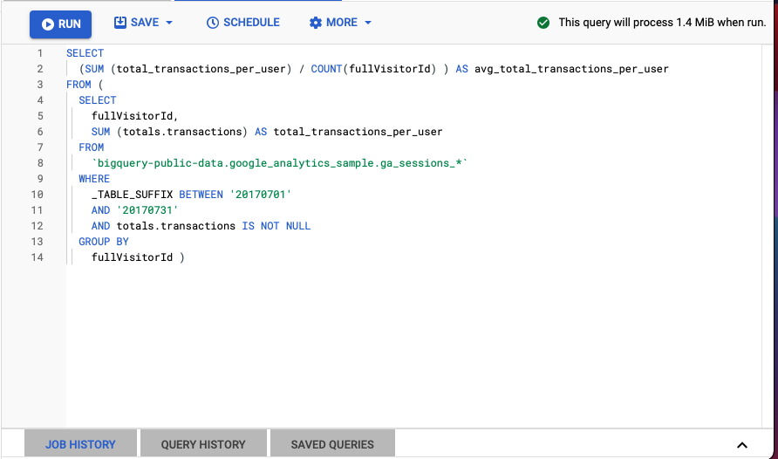

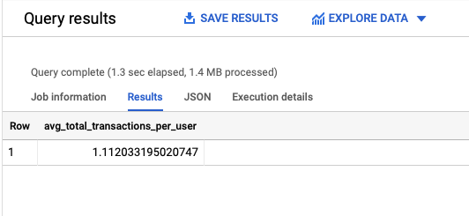

1. **What is the total number of transactions generated per device browser?**

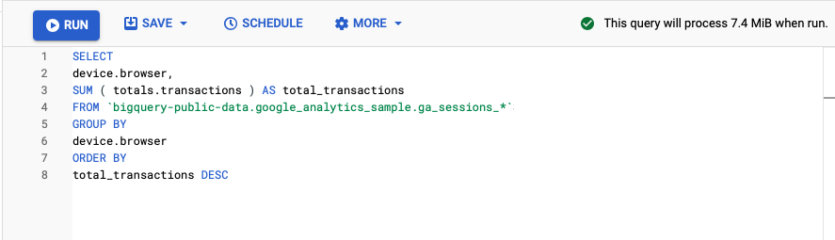

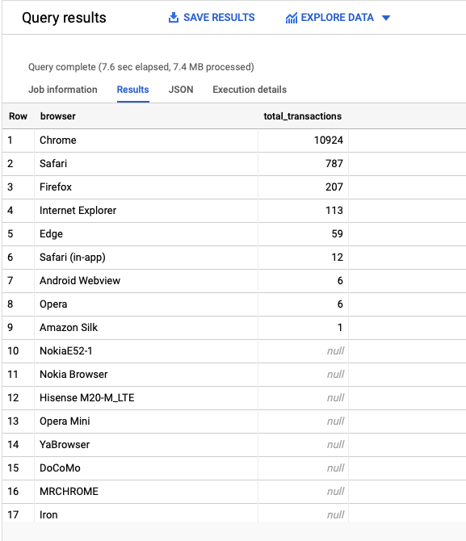

1. **Identify the top 5 browsers used for making transactions in July 2017, listed in descending order by total transactions.**

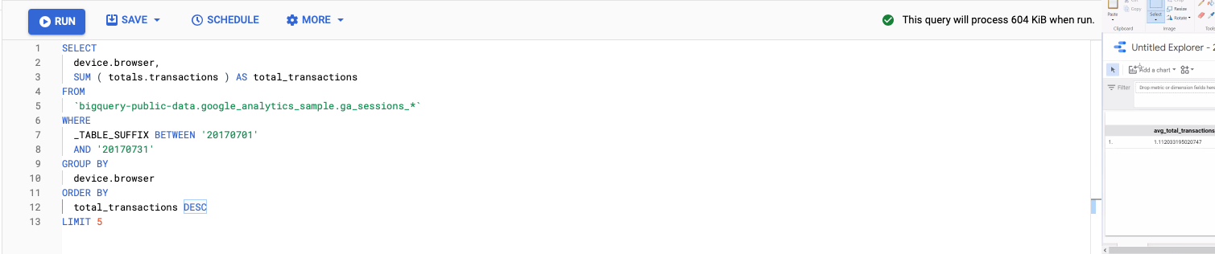

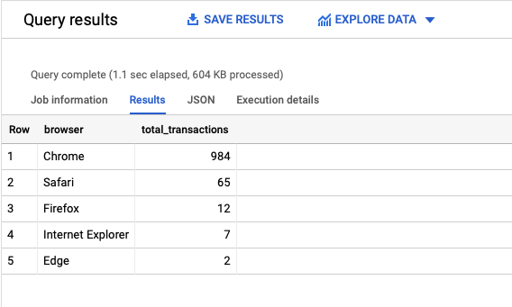

# 3 Lesson Learned

* Batch Queries can be run easily and tables can be created from the data
* BigQuery allows saving query results in a new table, so to create a new aggregated table
* We can scale out as the size of the warehouse grows, so there is no need to delete older data.